Neural Networks



We have 3 types of layers in a neural network,

1. Input layer
2. Hidden layer
3. Output layer

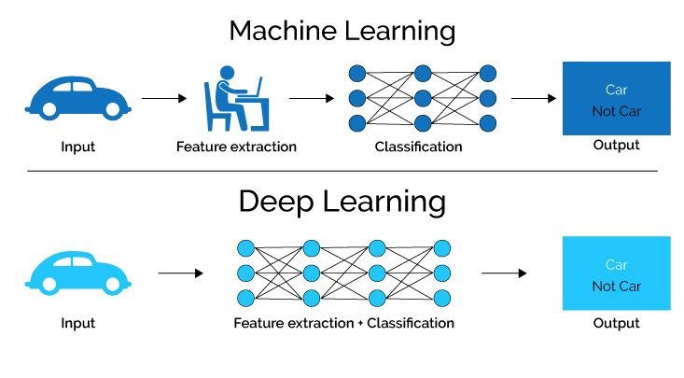

In deep learning, both Feature extraction as well as classification both is done by the machine itself whereas in machine learning, feature extraction is done by us and not by the machine.

Why do we need non-linearity (non-linear activation functions) in neural networks?  
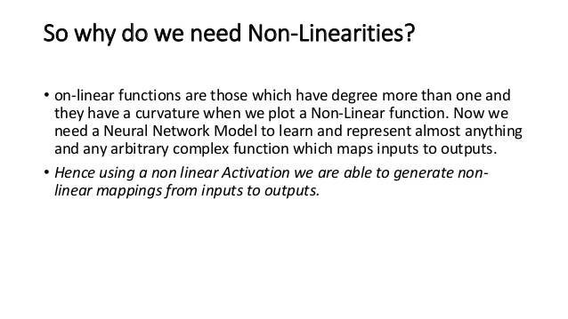

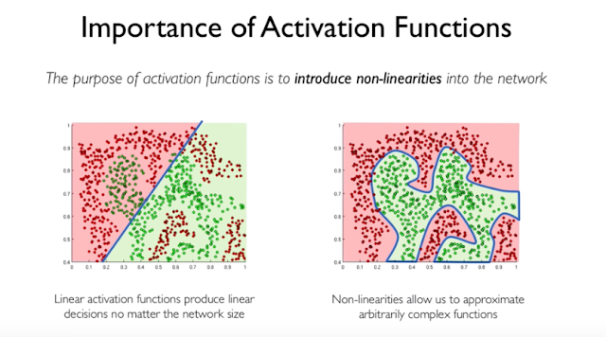

Deep learning problems are non-linear by nature and we can’t do predictions using a linear function.

There are 3 types of Neural Network

1. Artificial Neural Network (ANN).

2. Convolutional Neural Network (CNN).

3. Recurrent Neural Network (RNN).

Artificial Neural Networks (ANN)

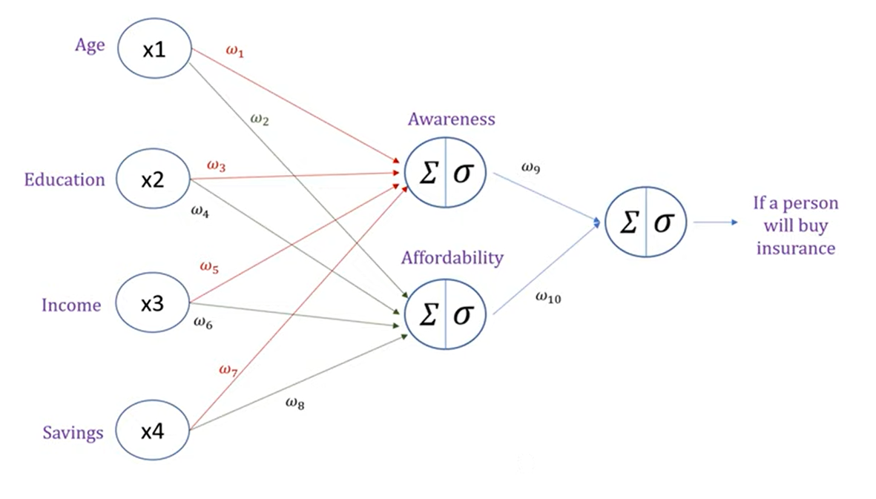

In AAN, we have 2 types of processes happening in our neural network,

1. Forward propagation
2. Backward propagation

Forward Propagation

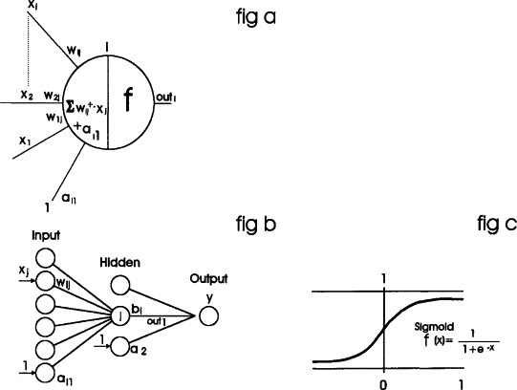

In forward propagation, every neuron does 2 steps which can be seen from fig 1 of above image,

* Calculates Z = (wi)*x + b // where wi = ith slope or weight
* Calculates sigmoid of resultant ‘Z’ sigmoid(Z) and passes the result to the next neuron of next layer with other weights and continues the same procedure till the output layer.

When the output (prediction y’) is made, an error is calculated using the cost function and now weights are adjusted(updated) and prediction value is calculated again by backpropagation to get predicted value with minimal error possible. The backpropagation will adjust(update) the weights in such a way that error is minimized.



Backpropagation





In Backpropagation process, when the output or a prediction is made using forward propagation, we go back from output layer till the first layer and update the weights. We do this backpropagation and forward propagation again and again, and stops when we get minimal error or best result. The weights(slopes) of each layer are updated using chain rule.

The Chain Rule

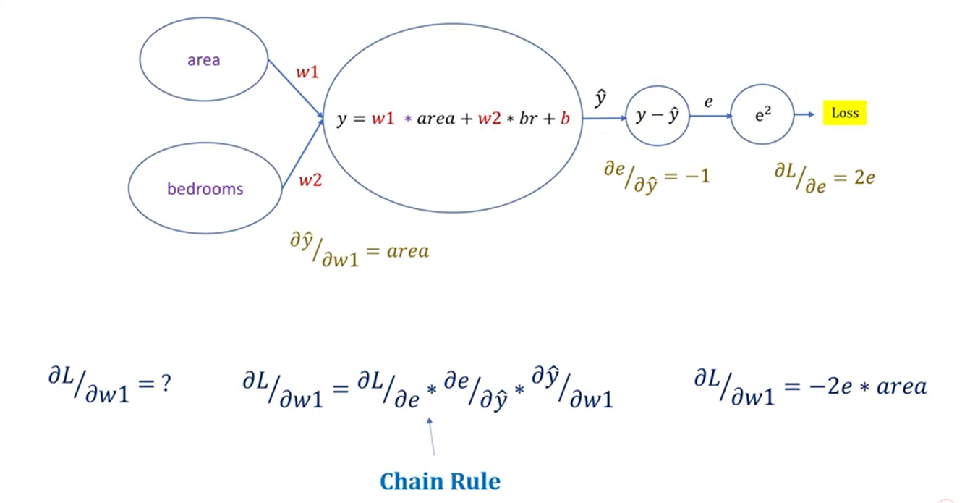

Note: The derivative here is partial derivative which means all other variables will be treated as constant except for the one with whom the derivative is being taken.

Slope 🡪 weights (we are actually updating slopes).

Here we calculated the partial derivative of Loss w.r.t partial derivative of weight#1 which will include all the slopes (partial derivatives) of the layers in between them. Similarly, if we want to find the slope or weight of any layers, then we will have to include partial derivatives (slopes) of the layers in between them.

Example#1,

Partial derivative of Loss / partial derivative of w2 = dL/de * de/dy * dy/dw2.

Weights or slopes are then updated using following equation,

W(old) = w(new) – learning rate * partial derivative which was calculated using the chain rule. (Gradient descent)

Example#2,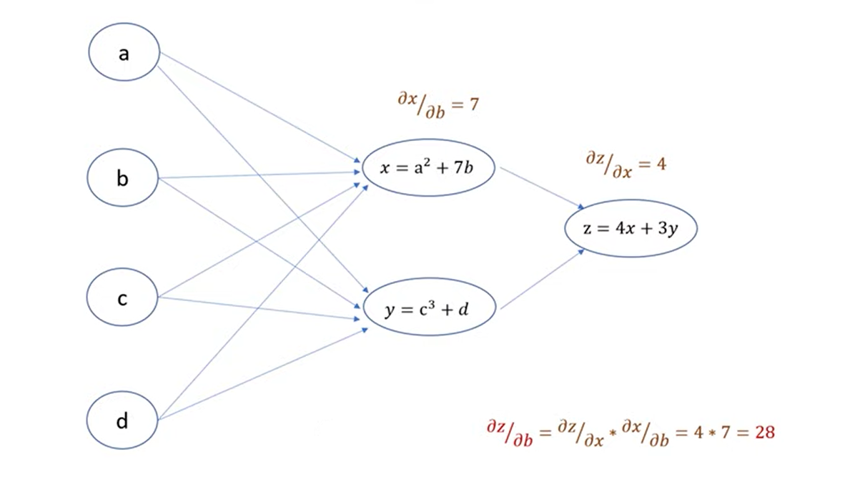The activation function of ANN can be sigmoid, softmax, relu, leaky relu, tanh etc.

Convolutional Neural Network (CNN)

**Convolutional Neural Networks**, or CNNs, were designed to map image data to an output variable. They have proven so effective that they are the go-to method for any type of prediction problem involving image data as an input.

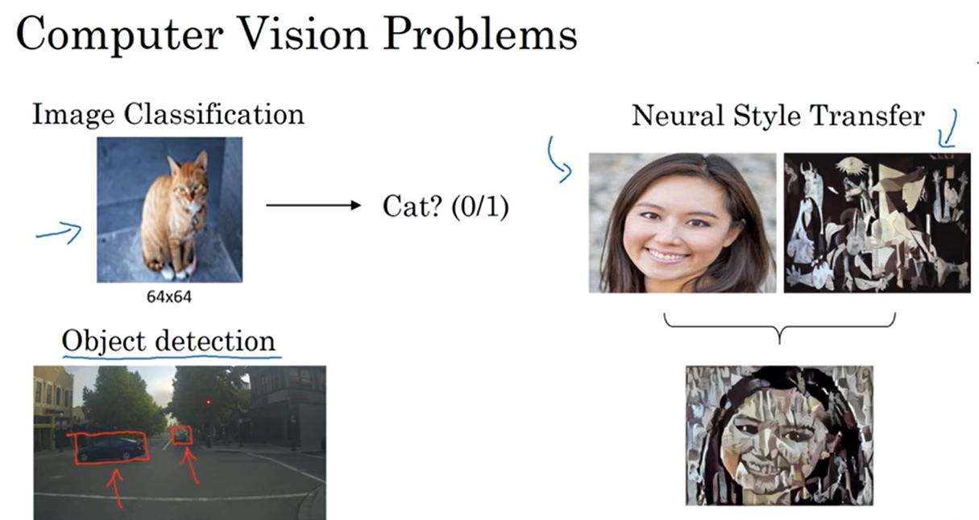

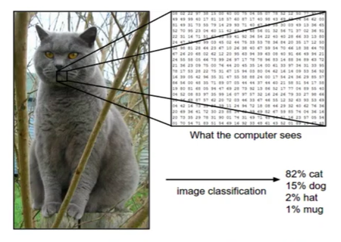

Everything we did in Artificial Neural Network (ANN) is included in CNN in its fully connected layer or dense layer. However, before going to the dense layer or the fully connected layer it has to come through many convolutional cycles or convolutional layers. The output of these convolutional layers is flattened (converted to 1D array) and are passed to the dense layer and then the remaining process is same as of Artificial Neural Network (ANN).



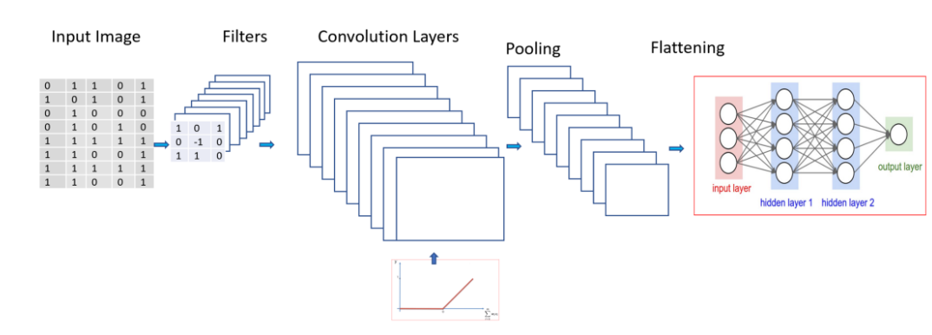

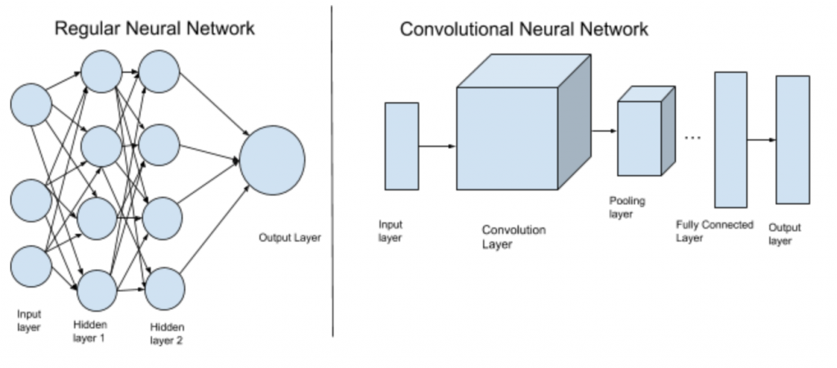

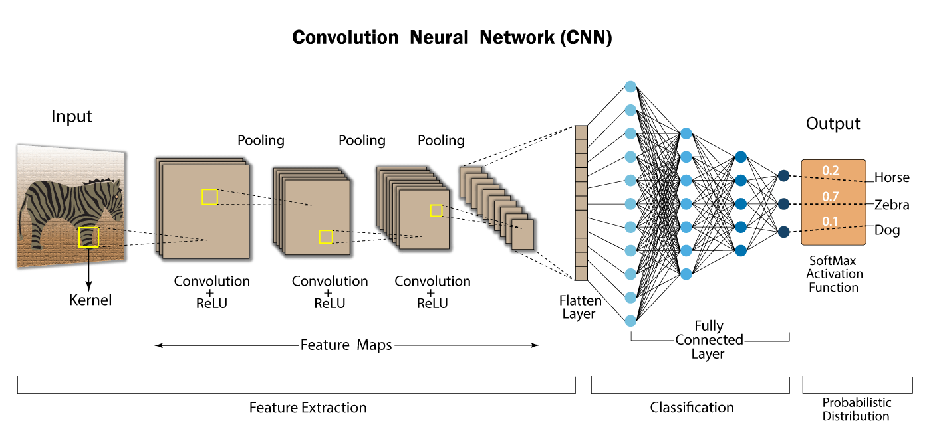

Feature Extraction is done by the convolution layers and after that the classification is done by the dense layer or the fully connected layer.



Convolution Layer (Feature Extraction Layer)

Each convolution layer in a CNN is used to extract a feature or is used to work on a feature. Suppose the first convolution layer finds the vertical edges, the second one finds the horizontal edges of object in the input image, the third one works on eyes, fourth on nose, fifth on hair and so on and after working on these features one convolutional layer merges all these features to construct the object and may pass the constructed object to the dense layer or the fully connected layer in the form of a 1D array (flattened array) and then that dense layer will classify that object.

A convolution layer includes following sub layers in it,

**Image (Input Layer) 🡪 Feature Extractor/Filter/Kernel 🡪 Feature Map 🡪 Bias 🡪 Activation function (Relu or Leaky Relu) 🡪 Convolutional Logic 🡪 Avg/Max Pooling(optional) 🡪 Back to feature extractor/filter/kernel.**

Again, the filter is applied to the resultant feature map of first output.

This cycle from Pooling **🡪**Feature Extractor/Filter/Kernel is continued and backpropagation is done until we find appropriate weights for our feature the machine will keep learning or back propagating until it finds relevant weights for the feature on which it was working.

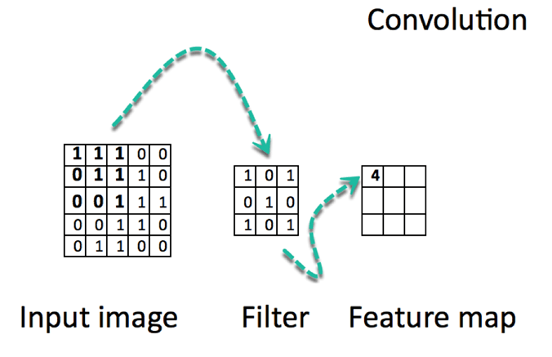

The dimensions of feature map can be calculated from the following formula,

Dimensions = [(image size - filter size + 2*padding) / total strides (filtering steps)] + 1.

**Strides**

Strides is the total gap or the skipped rows and columns during the movement of filter inside the image. In the image below, the value of stride is 1 because 1 row and 1 column are skipped during movement of the filter.



A CNN can have either a gray scale image of 1 channel or an RGB image having 3 channels in it (dimensions R, G, and B each of these 3 dimensions are equivalent to 1 gray scale image channel).

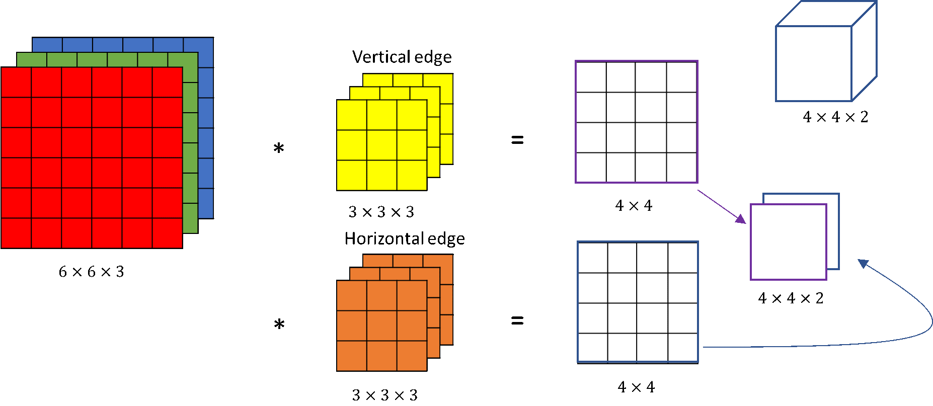

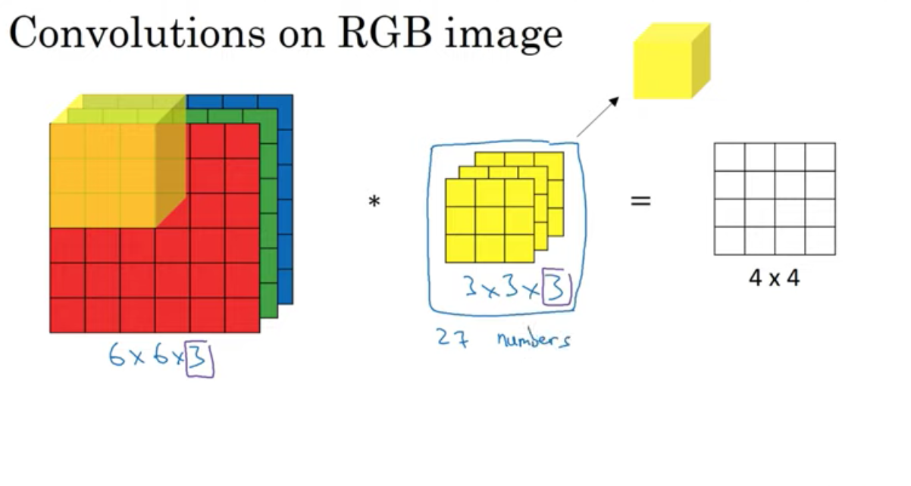



Feature map elements are the sum of the direct multiplication of image elements with the filter elements.

Example,

In the above image, the value 4 comes by multiplying and adding following,

1*1 + 1*0 + 1*1

0*0 + 1*1 + 1*0

0*1 + 0*0 + 1*1

=

1+1+1+1 = 4

This calculation of feature map can also be seen from the following image,







Once the feature map is calculated, a bias is added and activation function like Relu, leaky relu is applied in convolutional layers. We do not use sigmoid and softmax activation functions in convolutional neural network layers because they lead to vanishing gradient problem and exploding gradient problem. After applying activation function, we define a convolutional logic and then do pooling and then repeats the cycle from the filter and now our input for next iteration is our previous feature map.

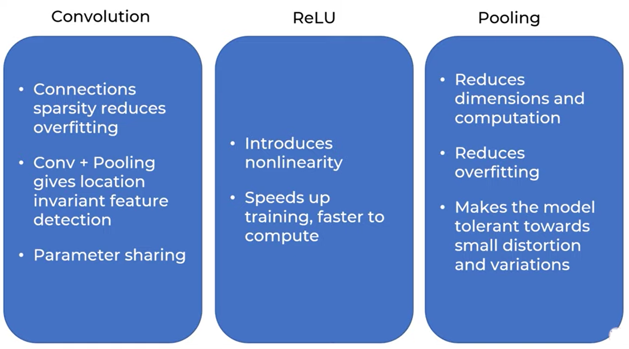

Padding

Padding is also added in original image in order to get feature map of size similar to the input image.

 

There are various types of padding but mostly we use 0 padding in which we initialize the rows and columns as 0. In other padding types we use neighbor values also.

Pooling

Pooling is a process through which we reduce the computation as well as the dimensions of the existing image and works only on important weights. The dimensions of the pooling matrix can be calculated using following formula,

Dimensions = [(image size - filter size + 2*padding) / total strides (filtering steps)] + 1.

There are basically 2 types of pooling.

1. Max pooling (max value is selected)
2. Mean pooling (Average of values is selected)

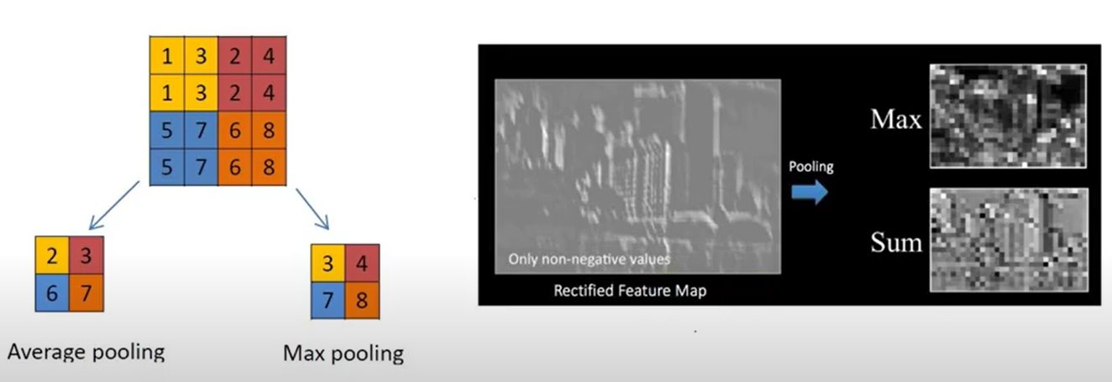





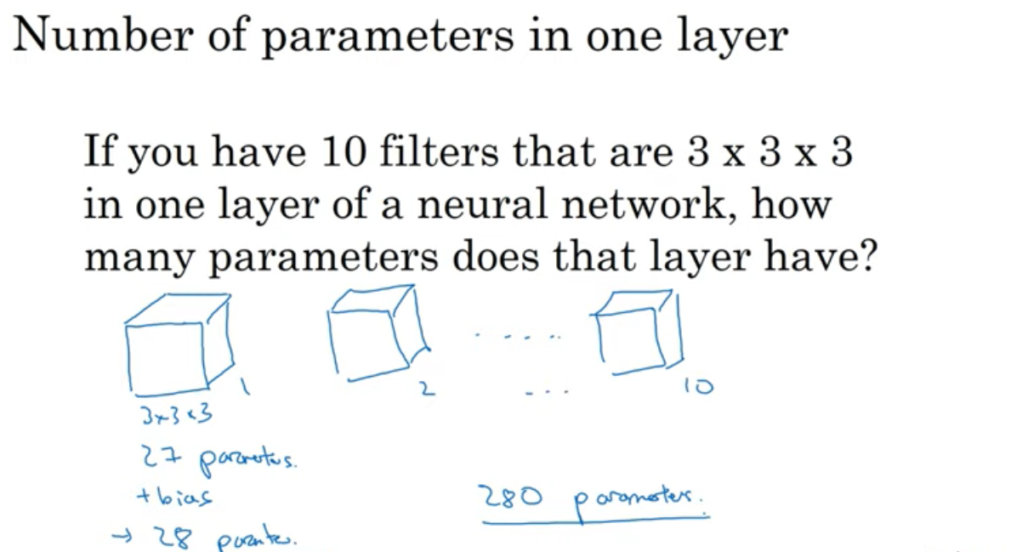

The Vanishing Gradient Problem

The Exploding Gradient Problem

Data Augmentation

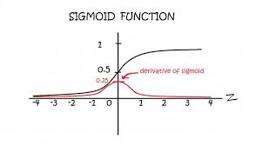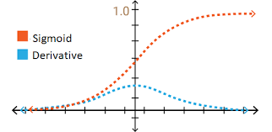

**YOLO Algorithm For Object Detection**

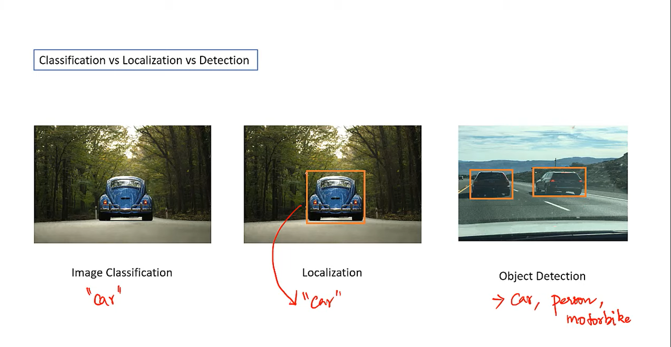

**Image Classification**

Labelling of an image on the basis of the object is called image classification. It is only for a single object.

**Localization**

It is similar to image classification but we draw a bounding box in the input image and label only that portion. It is also only for a single object.

**Object Detection**

Objection detection is similar to localization but it is for more than one object of different types.

**Bounding Boxes**

Bounding boxes are boxes that are predicted by the network. These predicted boxes are overwritten on the input image so that you can visually understand what the position or shape of rectangle are detected by the prediction. That is, they are rectangles you see in images or videos.

It has following parameters,

Bx 🡪 X co-ordinate of center of box

By 🡪 Y co-ordinate of center of box

Bh 🡪 height

Bw 🡪 width

**Anchor Boxes**

We can put some assumption on the shapes of bounding boxes. For example, if we want to detect humans, we should search humans with some vertical rectangular boxes. They are anchor boxes. The anchor boxes are fed to the network, before training and prediction, as a list of some numbers, which is a series of pairs of width and height:

anchors = [1.08, 1.19, 3.42, 4.41, 6.63, 11.38, 9.42, 5.11, 16.62, 10.52]

This list above defines 5 anchor boxes with 5 pairs of (height, width).

Total Objects/Classes = Total Anchor Boxes

For example,

A separate anchor box for human, car, bike, sofa etc.

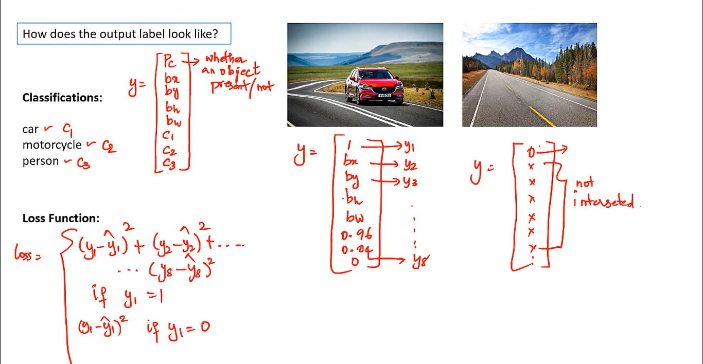

This output label Y contains following parameters,  
Probability count (Pc) 🡪 Probability of object detected from defined anchor box for an object.  
Bx, By, Bh, and Bw 🡪 They are parameters of bounding boxes that are also included in output Y.  
C1, C2, …, CN 🡪 Total classes/objects to be detected and only one class is true at a time in output label Y because output label Y represents a detected object of a specific class only.  
The loss is calculated by calculating the difference of each of these 8 (Pc, Bx, By, Bh, Bw, C1, C2, Cn) parameters that are described above with the same parameters of actual Y vector. The actual Y vector also contains all these parameters. But, if Pc OR the Y1(the first parameter is 0 or near to 0 or lesser than the threshold) then we say that there is no object and since when there is no object, we don’t need to calculate loss for other remaining parameters so we simple calculate the loss of probability count only.

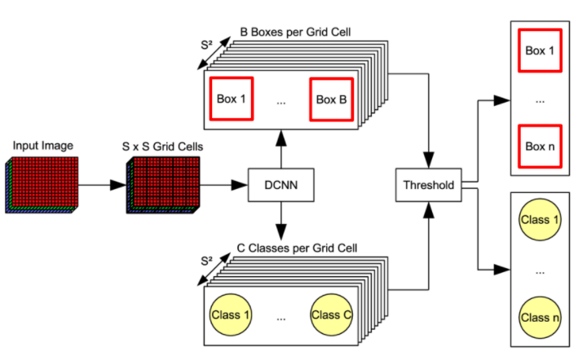

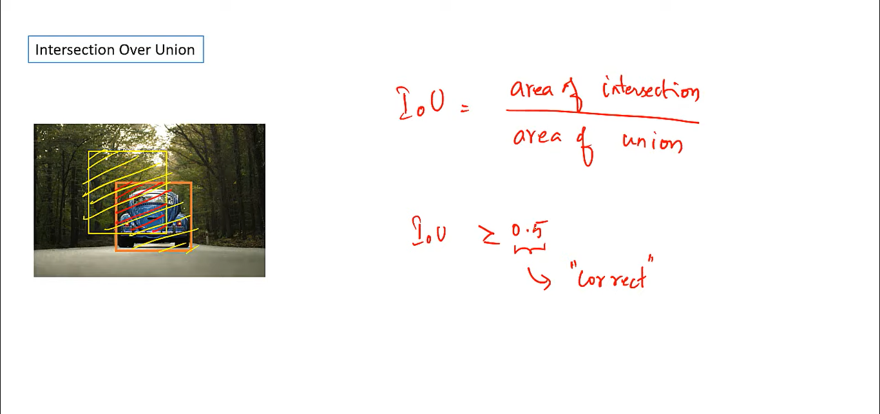

The intersection over union (IOU) helps us in determining which bounding box is more accurate because our model may predict multiple bounding boxes who has detected an object so in order to determine the accurate bounding box, we take intersection over union from the bounding box having maximum probability with the rest of the predicted bounding boxes and pick the one with highest IOU ratio. 0.5 is a threshold value, if IOU is >= 0.5 then we say the prediction is more accurate and if it is < than 0.5 then we say the prediction is not that much accurate. It means that it has max area covered with the bounding box having higher probability which means that we will have to reject other bounding boxes having iou > 0.5 because there already exist some bounding boxes covering the same area of current (accurate or the bounding box with max probability) this is done using **Non Max Suppression**.

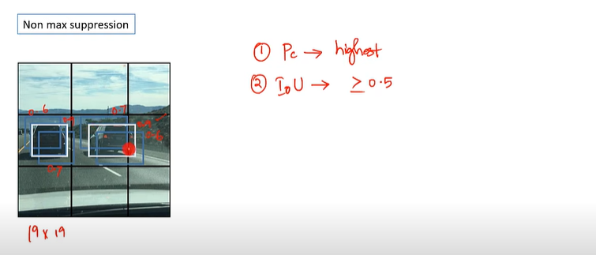

The following is the process of selecting the best bounding box using Non-Max Suppression.  
**Step 1:** Select the box with highest objectiveness score  
**Step 2:** Then, compare the overlap (intersection over union) of this box with other boxes  
**Step 3:** ‘**Remove**’ the bounding boxes with overlap (intersection over union) >50% or 0.5  
**Step 4:** Then, move to the next highest objectiveness score  
**Step 5:** Finally, repeat steps 2-4

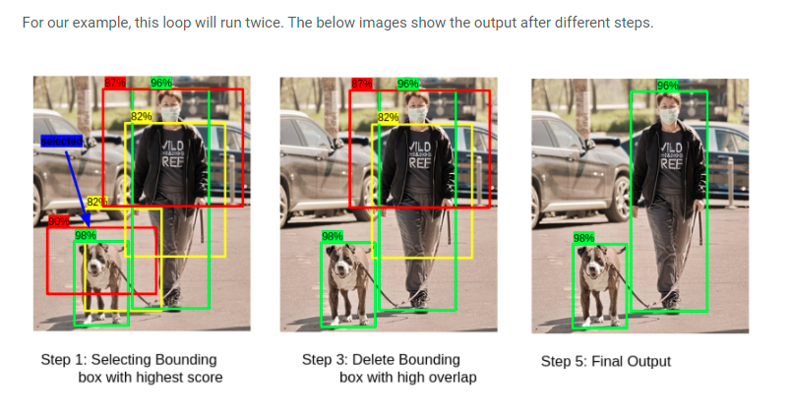

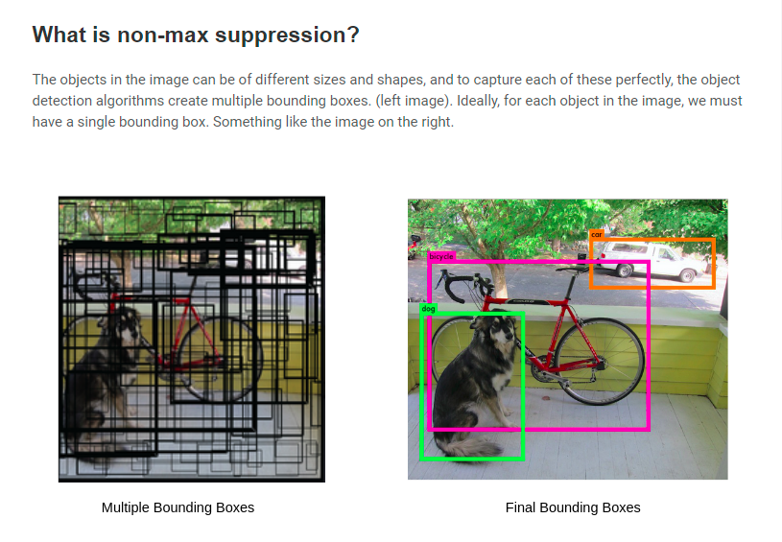

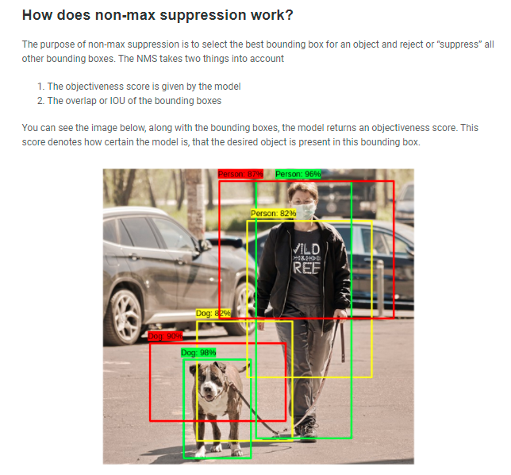

If two objects in an image have same center point then in order to detect such objects, we fed anchor boxes while training the model. Each object has its own anchor box now suppose if two objects have same center point in an image then we combine these anchor boxes together and merge them into one so our predicted Y vector or outcome label will look like,

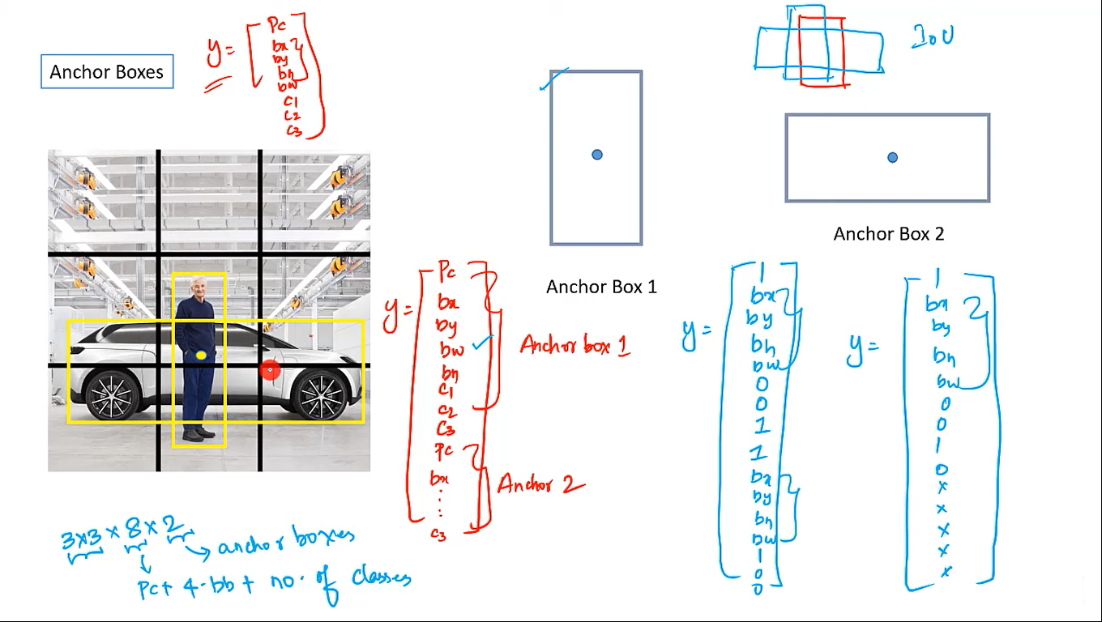

Once our Y or outcome label becomes like this, our model will then draw 2 bounding boxes covering both the detected objects.

**Limitations in YOLO**

cannot detect following:  
1. two anchor boxes and 3 objects with in a cell.  
2. two objects with same anchor box shape with in a cell.

These limitations can be addressed if we use a large grid size such as 19x19.

**How to select anchor boxes?**

1. Select by hand 8 to 10 most common shapes, which tend to cover most of  
the shapes  
2. Use unsupervised machine learning (such as K-means) to identify most  
common shapes within the dataset

How to select size What is the smallest size box I want to detect? If center of bounding box differs with center of anchor box, **we may miss the object detection**.

**How to detect objects using anchor boxes?**  
1. Create several (may be hundreds) of anchor boxes  
2. For each anchor box calculate which objects bounding box has highest overlap w.r.t IoU.  
3. If IoU >=50 percent detect the object with highest IoU  
4. else if IoU percent detection is ambiguous  
5. else if <40 percent ; no object

Region – CNN (R-CNN)

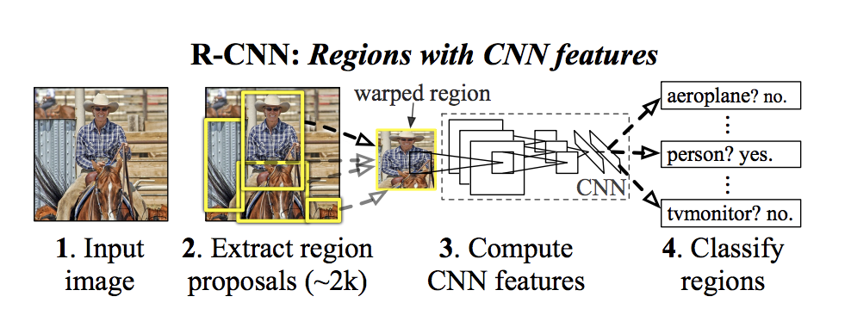

There are four attributes, which are used to form an object (scales, colors, textures, and enclosure).  
Regions are identified based on these attributes. Sub segments are generated to identify multiple regions. Similar regions are then combined to form large regions. Regions of Interest (RoI) are identified.

Recurrent Neural Network (RNN)

OR

Short Term Memory Neural Networks

Feedforward neural networks pass the data forward from input to output, while recurrent networks have a feedback loop where data can be fed back into the input at some point (self-loops in hidden layers, same hidden layer’s neurons can feed inputs/outputs to each other) before it is fed forward again for further processing and final output.

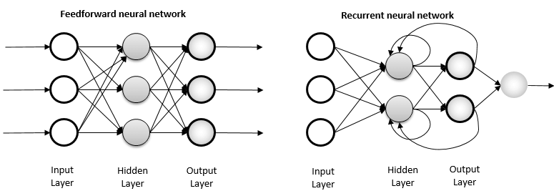  
  
  
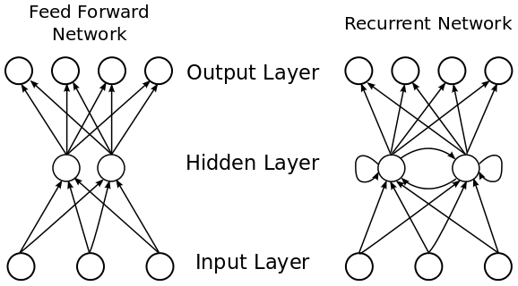

What makes Recurrent Networks so special?

A glaring limitation of Vanilla Neural Networks (and also Convolutional Networks) is that their API is too constrained: they **accept a fixed-sized vector as input** (e.g., an image) and produce a fixed-sized vector as output (e.g., probabilities of different classes). Not only that: These models perform this mapping using a fixed number of computational steps (e.g., the number of layers in the model). The core reason that recurrent nets are more exciting is that they allow us to **operate over sequences** of vectors: Sequences in the input, the output, or in the most general case both and it has a **short-term memory** that other neural networks like ANN and CNN does not have.

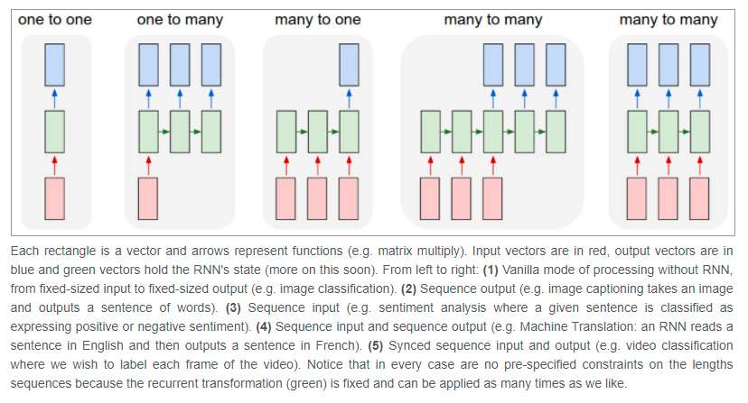

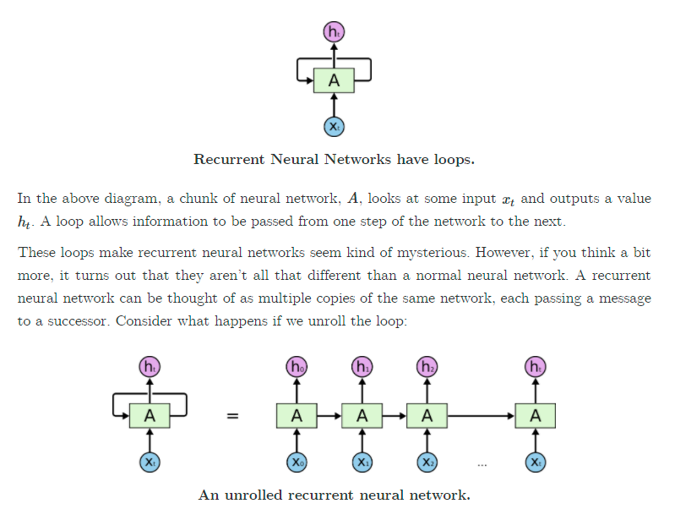

Here, the loop is also ht(output) which is an input for next layer at time t+1. Normally we represent the upper directed output with Y’ and loop output/input as ht which is same as Y’ for the first node only but when we go ahead in our deep neural network ht behaves as a short-term memory and it is no longer equivalent to output Y because it has previous layers output information also so ht=Y only at first node.

**Types Of RNN**

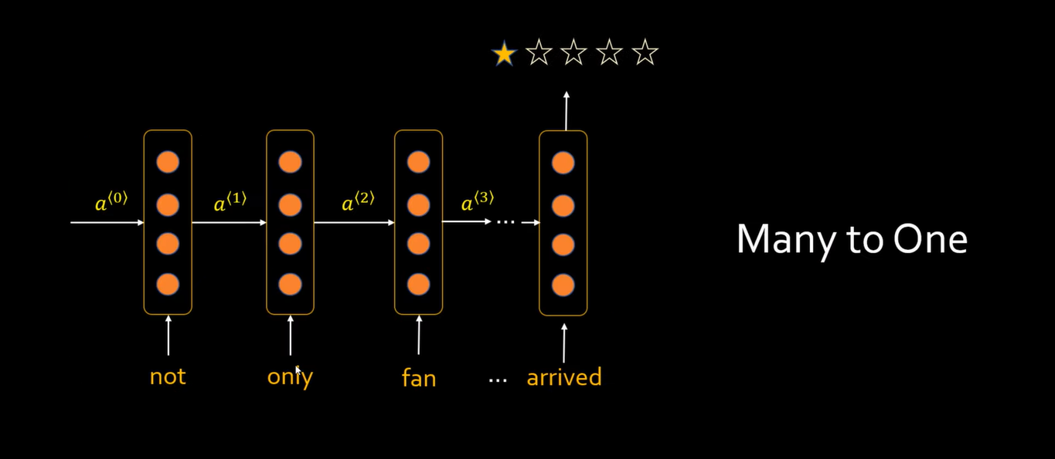

Here we have many inputs but only single output that is why we used Y’ at last node of RNN.

Similarly, in text classification problems (many-many) type of RNN when we have many inputs and many outputs, we will be using Y’ at each node of RNN,

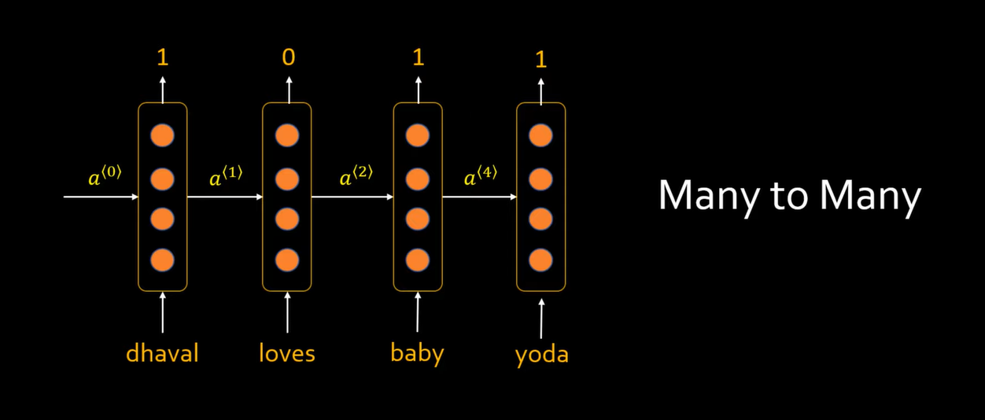

Here 1/0 represents the class of output. 1 represents class person for example Dhaval, baby and yoda and 0 represents non-person words like loves in the above example. For such neural networks, we use Y’ notation at each node of RNN.

Similarly, we have one more type of RNN which is one to many in which we have same input x for each node of RNN,

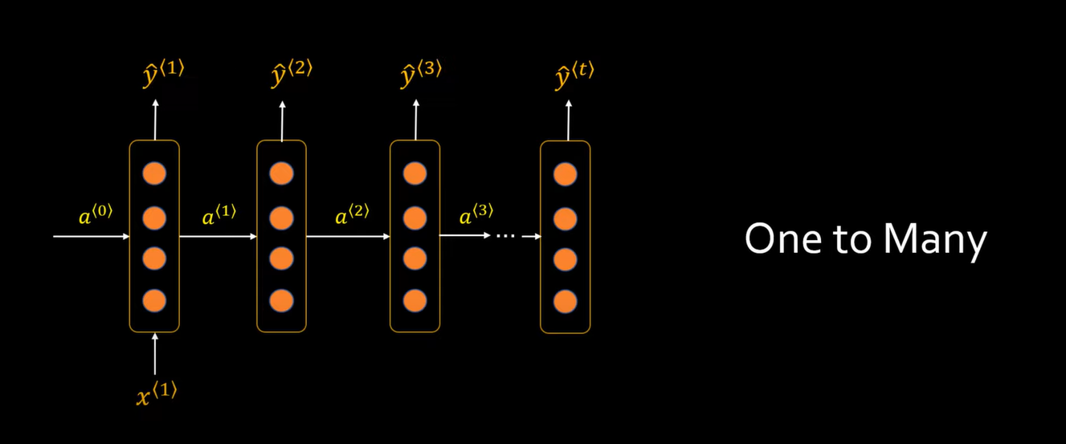

References

* <https://colah.github.io/posts/2015-08-Understanding-LSTMs/>
* Codebasics

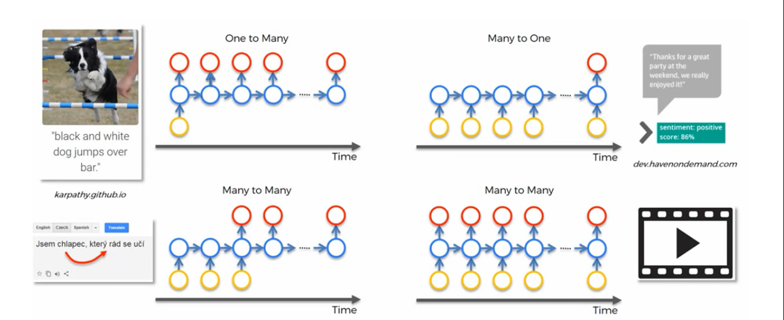

**Why RNN?**

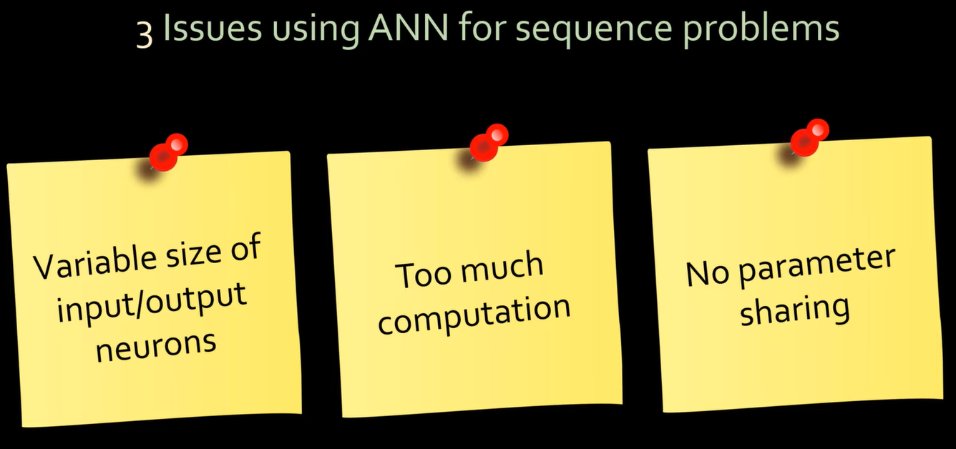

**Applications**

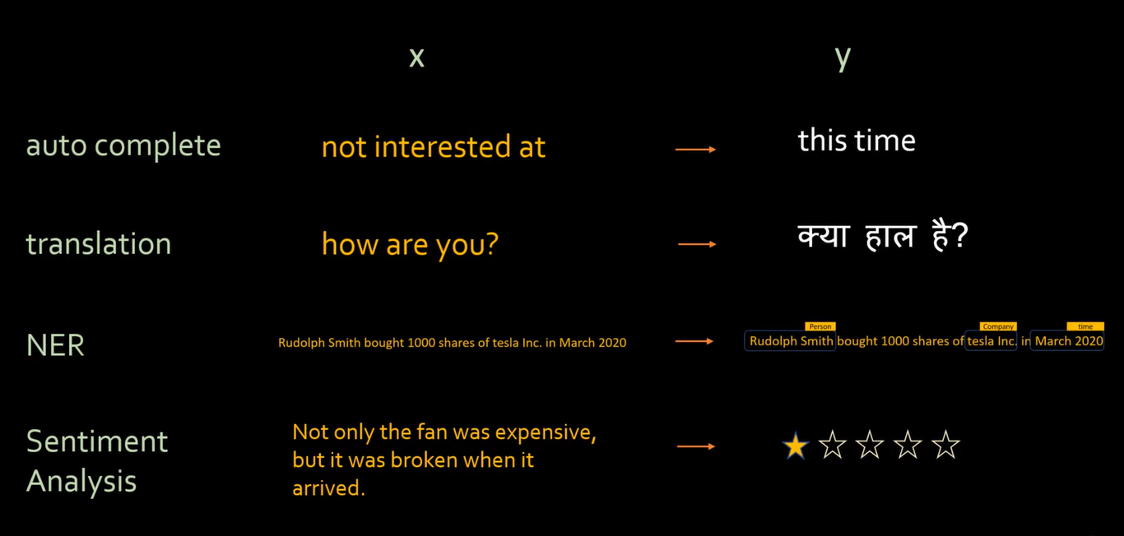

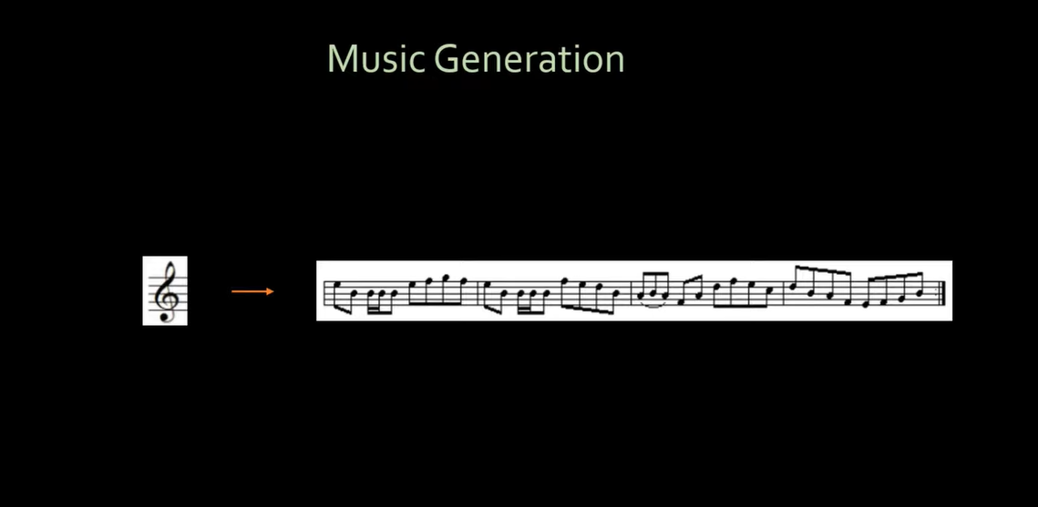

**Named Entity Recognition (NER)**

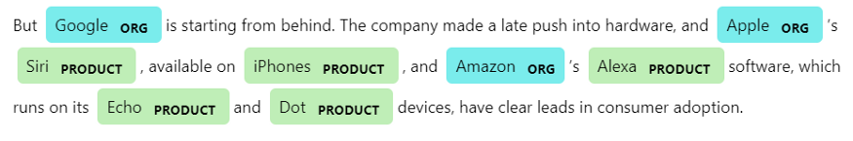

**Total Loss**

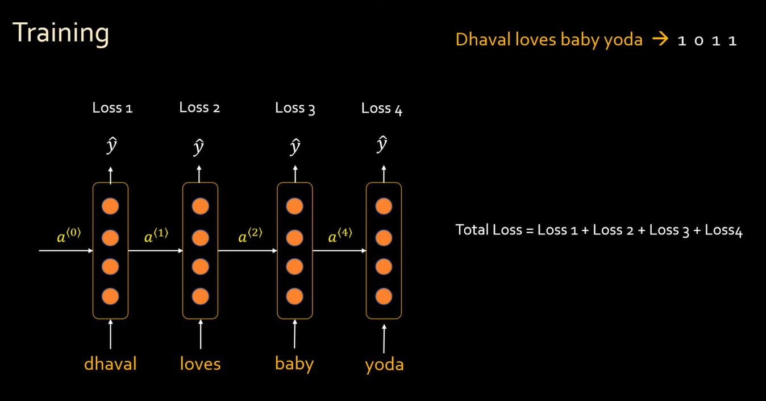

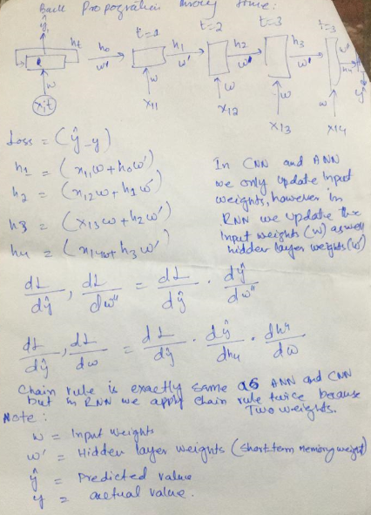

**Problems with Simple RNN**

The problem with simple RNN is that it has very short memory. For example, suppose if we have 10 words in a sentence and we want to predict the last word of the sentence then RNN will be having knowledge of just few words that it has read at end in the network let say last 3,4 words and not all 10 words because it has very short-term memory. However, it should have knowledge of all the 10 words to predict the last word because last word depends on the entire sentence and on the basis of just few words, we can’t predict the last word accurately. The is called **“long-term dependency”** problem. This problem occurs due to the **“vanishing gradient problem”** in simple RNN. The vanishing gradient problem occurs because while back propagating, the older inputs (words) have no more relation/link with current words in memory of hidden state (short-term memory) so the gradient on such non relatable words/inputs become non-changeable and therefore the vanishing gradient problem occurs.

Suppose if we have two sentences that are 99% similar and are little different and if we want to do prediction of words on such sentences then we need knowledge(context) of entire sentence to predict accurately otherwise we can’t predict accurately. The example below shows that when we have “Today” we predicted “need” but when we have “Last year,” we predicted “had”. Such predictions can’t be done using RNN because, it has short term memory and it can have knowledge of just few read words. The gradient at node of word “Today” and “Last year,” during the back propagation has **no impact** due to which we have vanishing gradient problem. We have two solutions available to solve this problem, LSTM and GRU.

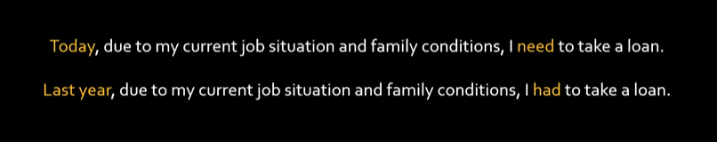

Simple RNN is like hero of film memento who has a very short-term memory due to which he forgets things too early.



As time passes, the impact of the words read earlier gets reduced,





In simple RNN, it is very hard to store the information of previous hidden layers. As the network grows (deep neural network with more hidden layers), the memory or information in previous layers is vanished.

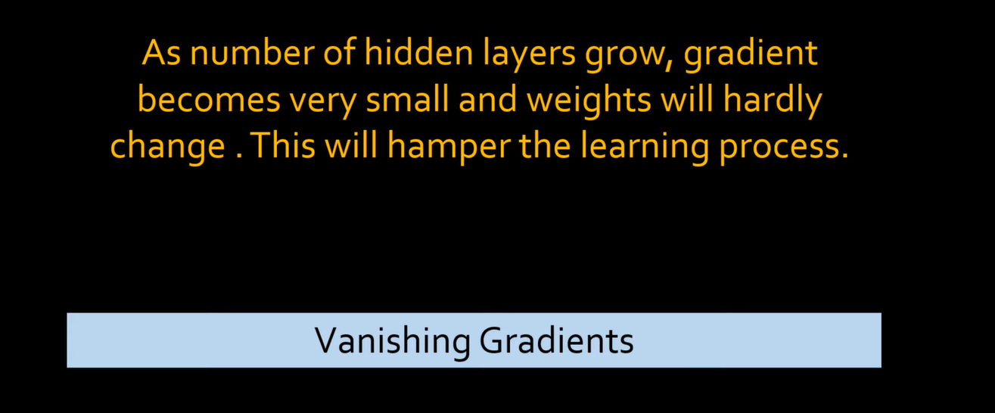

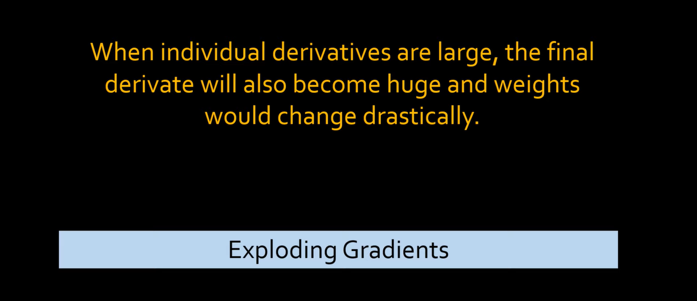

**Vanishing Gradient Example**  
wi = wi-1 + learning rate * some partial derivative value

w0 = 5  
w1 = 5 + (0.5) // here the second value ‘0.5’ is an assumption just to get the concept  
w2 = 5.5 + 0.25 // here the second value ‘0.25’ is an assumption just to get the concept  
w3 = 5.75 + 0.01 // here the second value ‘0.01’ is an assumption just to get the concept  
w4 = 5.76 + 0.000001 // **“vanishing gradient problem (weight stops changing)”**

**Exploding Gradient Example**  
wi = wi-1 + learning rate * some partial derivative value

w0 = 5  
w1 = 5 + (10) // here the second value ‘0.5’ is an assumption just to get the concept  
w2 = 15 + 100 // here the second value ‘0.25’ is an assumption just to get the concept  
w3 = 115 + 1000 // here the second value ‘0.01’ is an assumption just to get the concept  
w4 = 1115 + 10000 // **“Exploding gradient problem (The change in weights is too much)”**

**Simple RNN Structure**

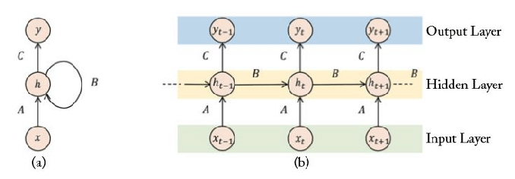

Ht = tanh((wx+b) + (w’ht-1 + b’))  
 **OR**  
ht = tanh (W (x, ht) +b) where W represent both weights 🡪 (w,w’)

Simple RNN (Short-Term memory) node memory using hidden layers,

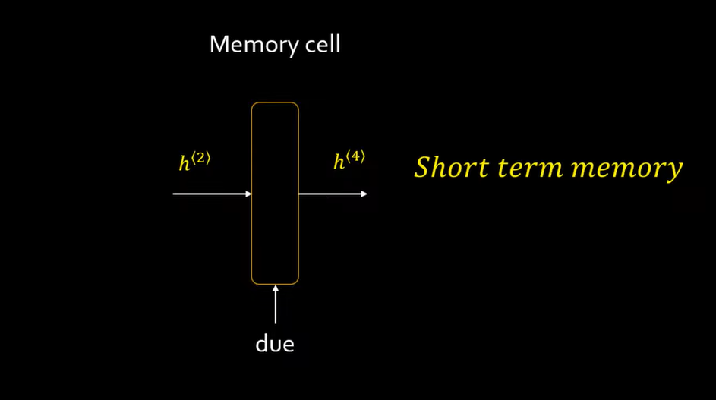

**Long Short-term Memory (LSTM) RNN**

LSTM (Long Short-Term Memory) RNN node,

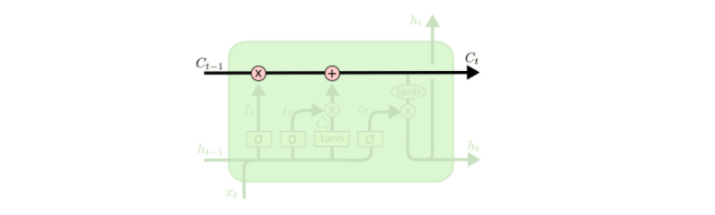

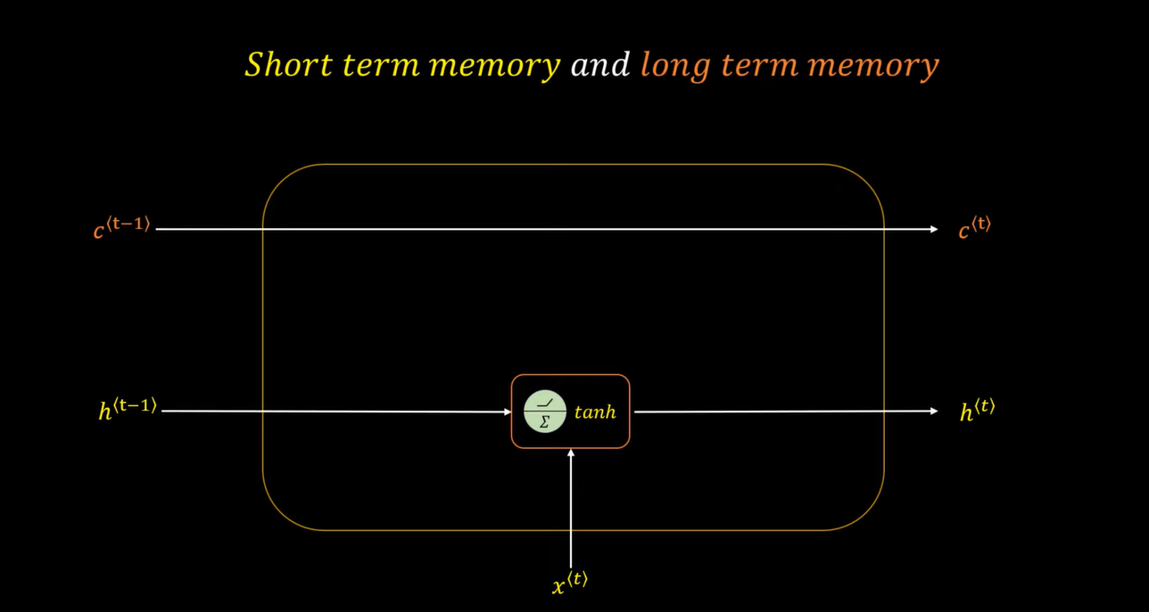

From the above images, we can see we now have an extra Long-Term memory (cell state) which we have named ‘C’ where t, t-1 represents the time intervals of memory at any node. C^t-1 represents the Long-Term memory at previous node/state whereas C^t represents Long-Term memory at current node/state.

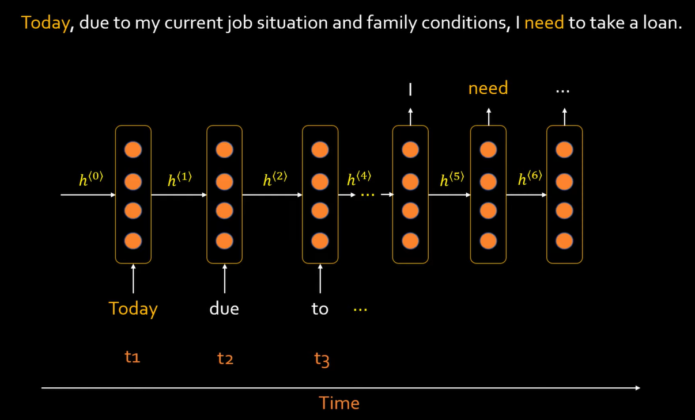

**Problem with simple RNN (short-term memory)**

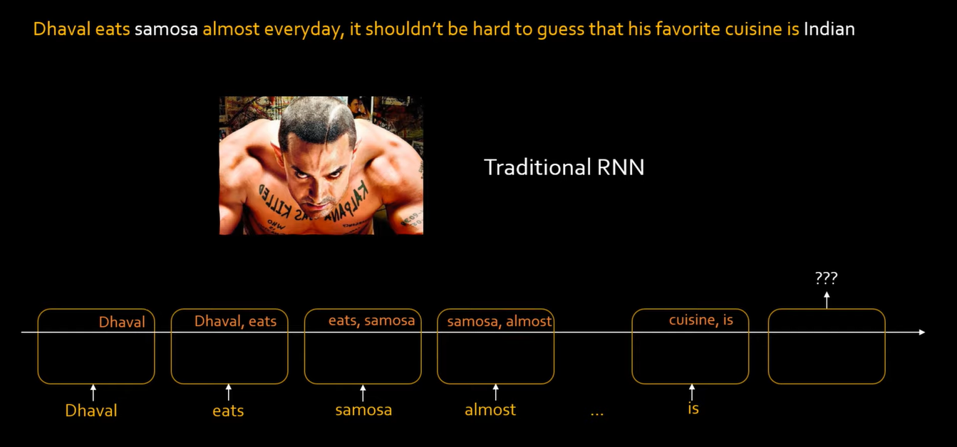

From the above image, we can see that simple RNN has very short memory for the purpose of understanding here let say, the simple RNN can only remember 2 important words at a time. Here we are determining the cuisine on the basis of previous inputs(food) like here we read samosa and based on this input out prediction should be Indian cuisine but since we are using simple RNN, we cannot have ‘samosa’ in our short-term memory for a **very long time** and hence this simple RNN can not predict the cuisine accurately. This problem arises because the sentence was long (long-term dependency).

Same sentence using LSTM,

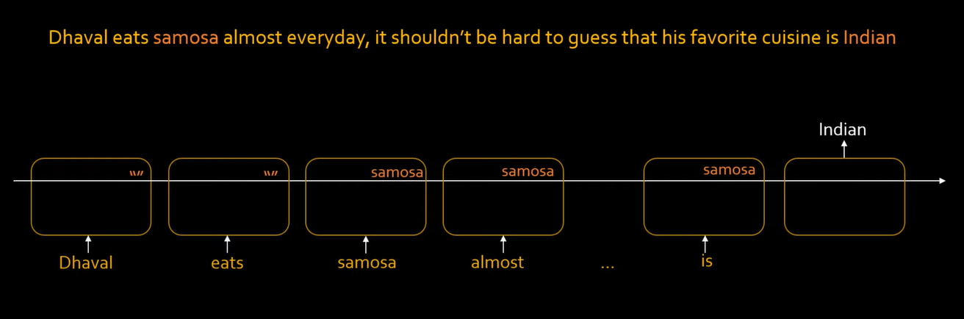

Here when we are using LSTM, we can see we have samosa (an important input) for a long time in the memory of RNN which helped in predicting the cuisine. The deep neural network will determine itself that what input(words) are important for prediction and what are not after the training with millions of inputs that is why we see that only samosa is placed inside the long-term memory of LSTM in the above example.

**Context Change In LSTM**

Similarly, if we take another long sentence to predict the cuisines, we see that for some time in the long-term memory we have samosa and we predicted Indian cuisine and even after prediction we still have samosa in our long-term memory but when the LSTM reads ‘Pasta’ it determines that the **Context** is now changed because during training phase, thousands of examples are given to the model and it can know which information to keep and which to forget or when the context is changing and when the context is not changing. The LSTM RNN will learn that samosa has no relation with pasta so it will change the context and it will remove samosa from the long term memory and add pasta in its place and that is the reason we predicted ‘Italian cuisine’ accurately for Dhaval’s brother otherwise if we had samosa in our long term memory instead so we would have predicted Indian cuisine which is wrong so the LSTM also knows when to remove inputs from the memory that is when to change the context and when to not change the context.

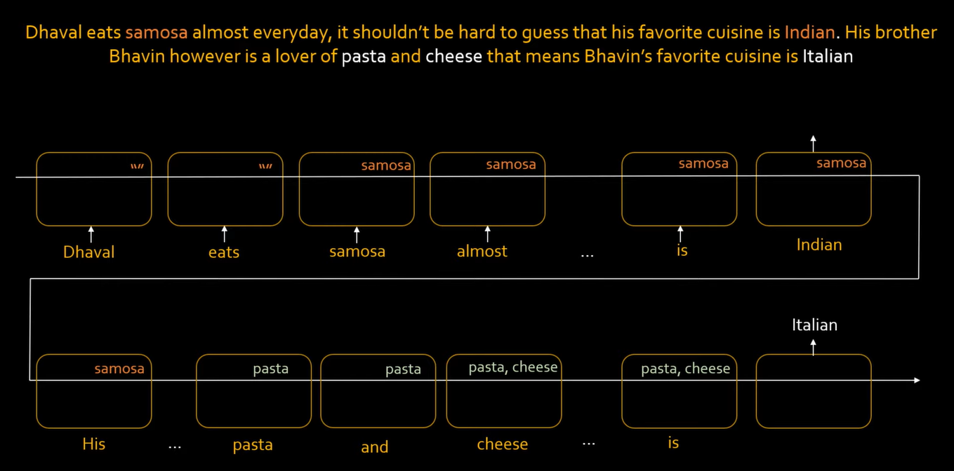

**LSTM Structure**

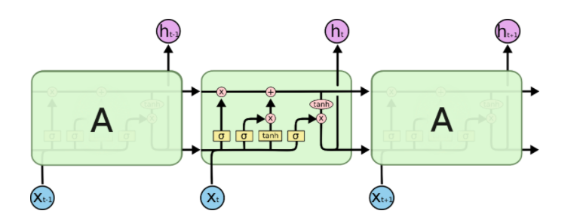

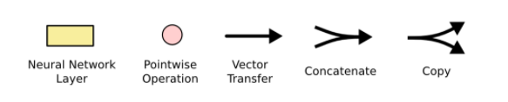

Here, the multiplication is not simple matrix multiplication but it is a pointwise/piecewise multiplication or the Hadamard multiplication. The example of Hadamard or pointwise/piecewise multiplication can be seen as,

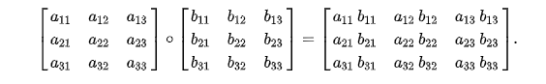

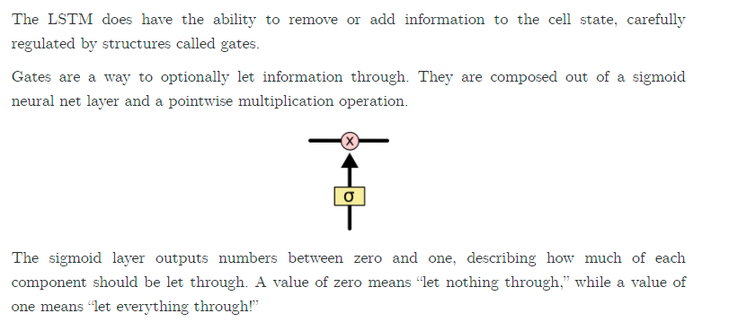

In LSTM, we have 3 types of gates,

1. The forget gate.
2. The Input gate.
3. The output gate.

**The Forget Gate**

The forget gate helps us in determining which information from the previous output(ht) should be kept with current context input(x). Remember the example of samosa and pasta that we discussed earlier where we forgot samosa when we read pasta to predict the Italian cuisine. This forget of samosa was done using this forget gate in LSTM. Similarly, let say we are predicting him/her on the basis of he/she, we sometimes have to forget he when she comes as new input and similarly, we will have to forget she when he comes as new input in order to predict him/her in current context.

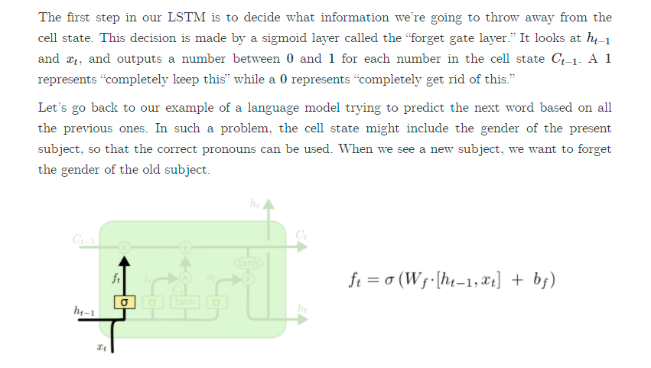

We have used sigmoid here because it gives values between 0 and 1 but after setting the threshold it helps us in getting only two values either 0 or 1. The 0 represents data is forgotten and 1 represents data to keep in cell memory ‘C’.

Here ‘Wf’ is basically a combination of two weights ‘Wf’ 🡪 (wi, wj). Let say the first weight ‘wi’ will be multiplied with the previous layer output ‘ht’ and ‘wj’ will be multiplied with current input ‘xt’ and then these matrices are concatenated together and a bias is then added to it. A sigmoid function is applied to it to determine which words(values) to forget from the cell and which words(values) to keep in the cell memory. 0 🡪 forget and 1 🡪 keep. A pointwise or piecewise multiplication is done between ft and ct-1 to forget/keep things from the cell memory that are only related to current context only.

Sigmoid specifically, is used as the gating function for the three gates (in, out, and forget) in LSTM, since it outputs a value between 0 and 1, and it can either let no flow or complete flow of information throughout the gates.

Therefore, current memory cell equation becomes,

Ct = Ct-1 * ft

**The Input Gate**

**The purpose of input gate is to forget things that has no relation with current input**. The input gate is used to input only new ‘relevant’ information that is important for current context and should be kept in memory cell ‘C’. For example, in the example of cuisine we discussed earlier that when we read ‘pasta’, we forgot ‘samosa’ because these words have no relation in current context. This new information of current context is placed using the input gate. Similarly, when we were reading ‘Cheese’ after reading pasta, we knew that these words are related to each other so we did not forget ‘pasta’ so all these things are done by the input gate.

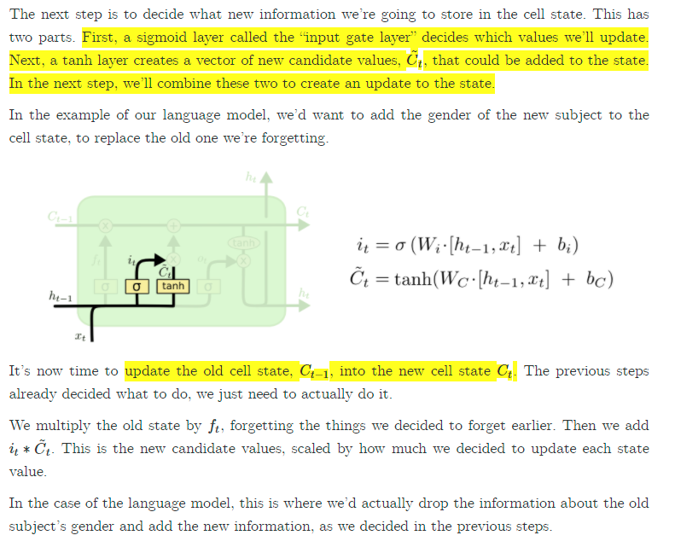

We multiply ‘it’ with new information to be kept ‘Ct’ and then add this information in the new cell memory state becomes,

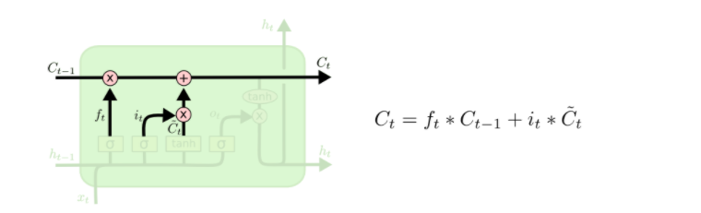

**The Output Gate**

The output gate is used to filter out the relevant information that is only needed for short-term memory (hidden layers). The LSTM will learn what is relevant for hidden state (what words are important for short term memory) and what is not relevant during the training phase so we do not need to worry about that. Suppose words like the, to etc. are not important so using output gate, we are able to filter only important keywords that are important for short term memory but comes too early in the network so due to long term dependency the impact/importance get reduced so in order to achieve that importance, we filter out the information using the output gate to keep only relevant information in our short-term memory.

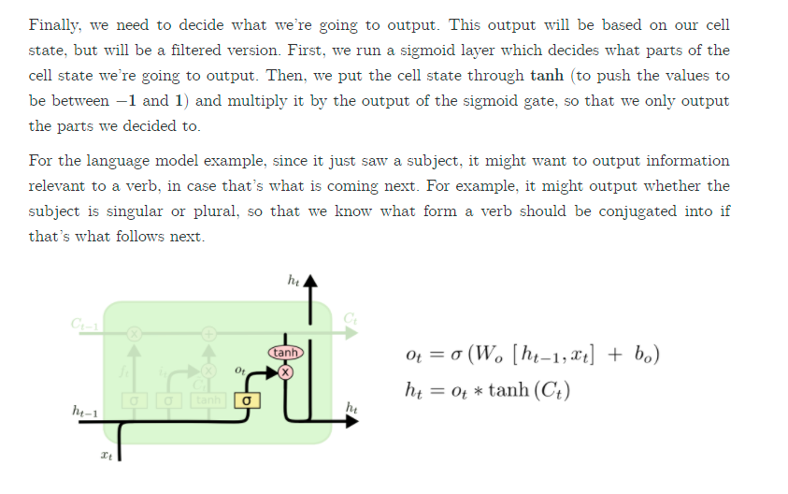

**Why Tanh function?**A **tanh** function ensures that the values stay between -1 and 1, thus regulating the output of the neural network. You can see how the same values from above remain between the boundaries allowed by the **tanh** function. So that's an **RNN**.

To overcome the vanishing gradient problem, we need a function whose second derivative can sustain for a long range before going to zero. Tanh is a good function with the above property. Tanh increases the derivative which helps in avoid the vanishing gradient problem because now derivative range is increased and is not from 0 🡪 0.25 like sigmoid.

A good neuron unit should be bounded, easily differentiable, monotonic (good for convex optimization) and easy to handle. If we consider these qualities, then we can also use RELU in place of the tanh function since they are very good alternatives of each other. But, before making a choice for activation functions, we must know what the advantages and disadvantages of our choice are.

**Summary**

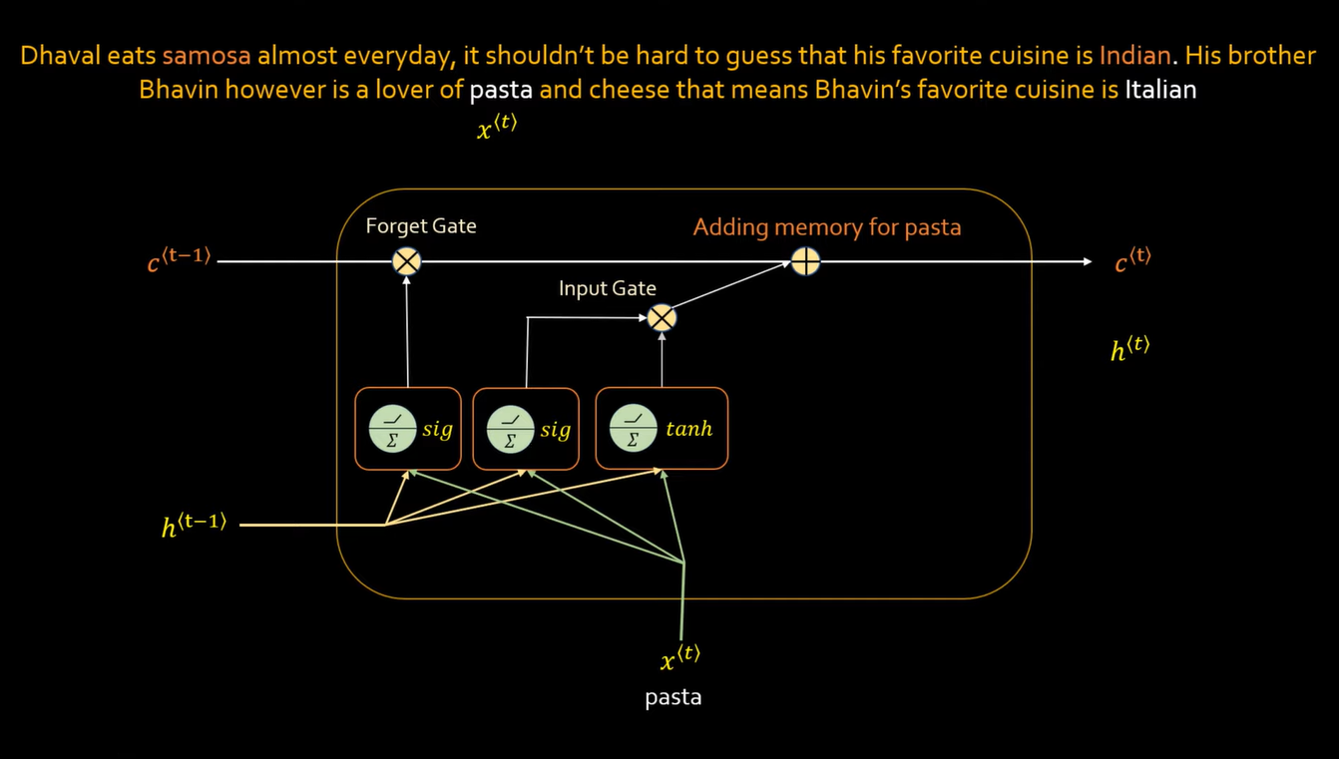

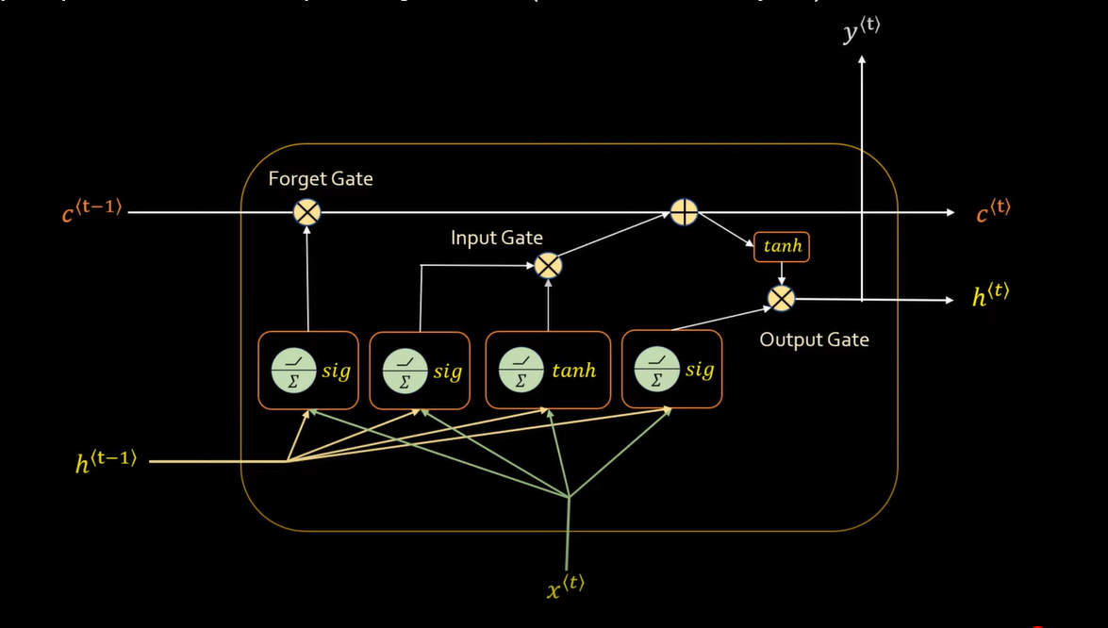



 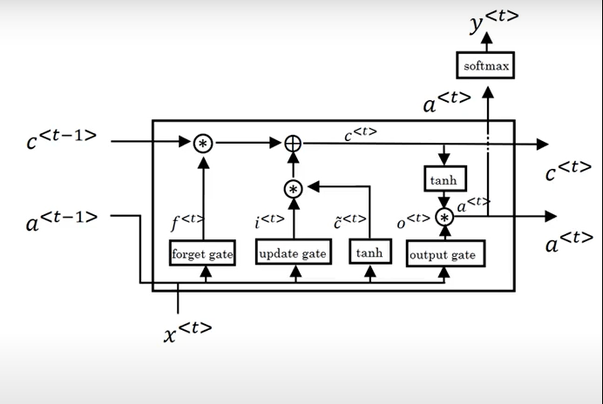

**Gated Recurrent Units (GRU)**

It is another variant of LSTM which solves the vanishing gradient problem and has a long-term memory like LSTM. It reduces the number of gates to 2 and it also do not have any cell memory like LSTM.

There are two gates in GRU,

1. The Reset Gate.
2. The Update Gate.

**The Reset Gate**

The Reset gate helps in forgetting the previous information whenever a context is changed and helps in putting the new information in hidden memory ‘ht’. It tells us when to forget the previous information and when to not on new inputs (if context is changing). The example below shows that when pasta was read (the context was changed) so samosa got forgotten and pasta was added as new information of new context. The equations of the reset and update gates are almost same and the only difference is of weights. In Reset gate, we have weights ‘Wr’ and ‘Ur’.

r^t 🡪 Represents Reset gate.

r^t = sigmoid ((new input at time t * its weights ‘Wr’) + (previous hidden layer output at time t-1 * its weight ‘Ur’))

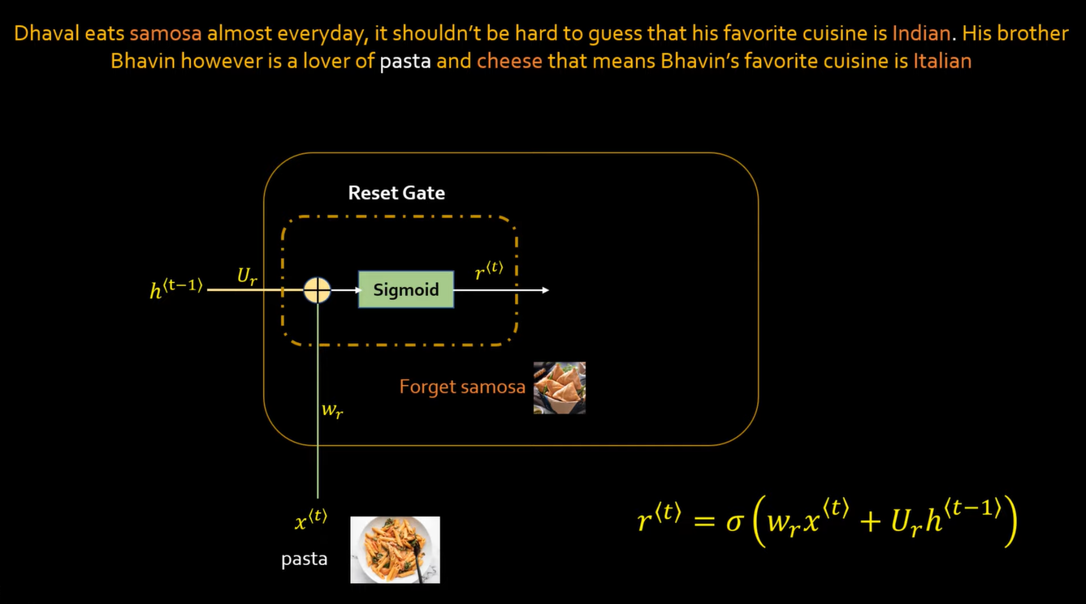

**The Update Gate**

The update gate helps us in telling what information to save/retain, if new words and the words in memory ht are of same context then retain/save it. The example below shows that when cheese was read (the context was not changed) so ‘pasta’ was retained in memory and cheese was added as new information of same context. The equations of the reset and update gates are almost same and the only difference is of weights. In Update gate, we have weights ‘Wz’ and ‘Uz’.  
z^t 🡪 Represents Reset gate.  
z^t = sigmoid ((new input at time t * its weights ‘Wz’) + (previous hidden layer output at time t-1 * its weight ‘Uz’))

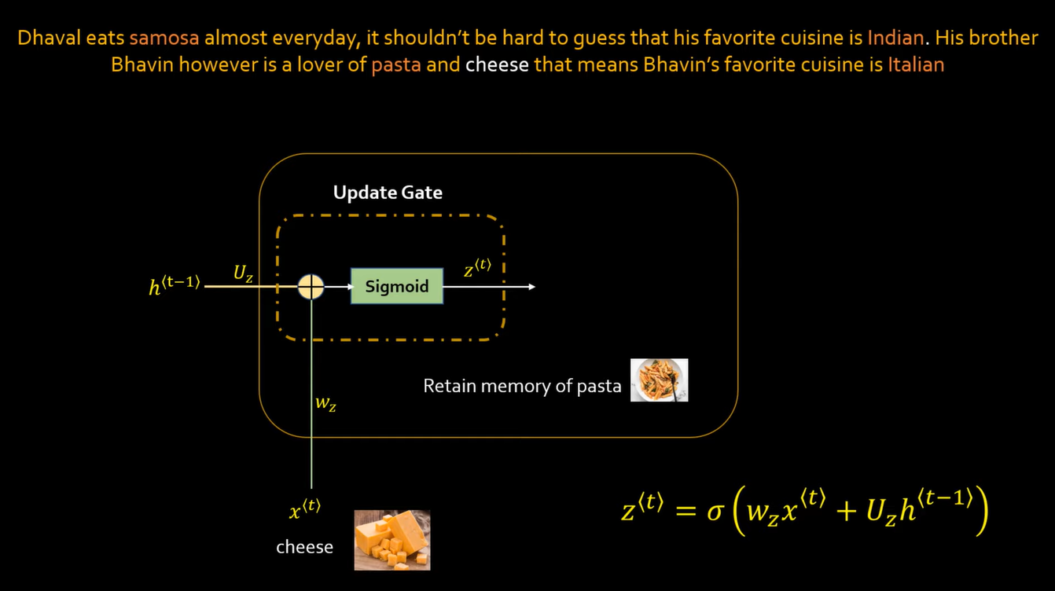

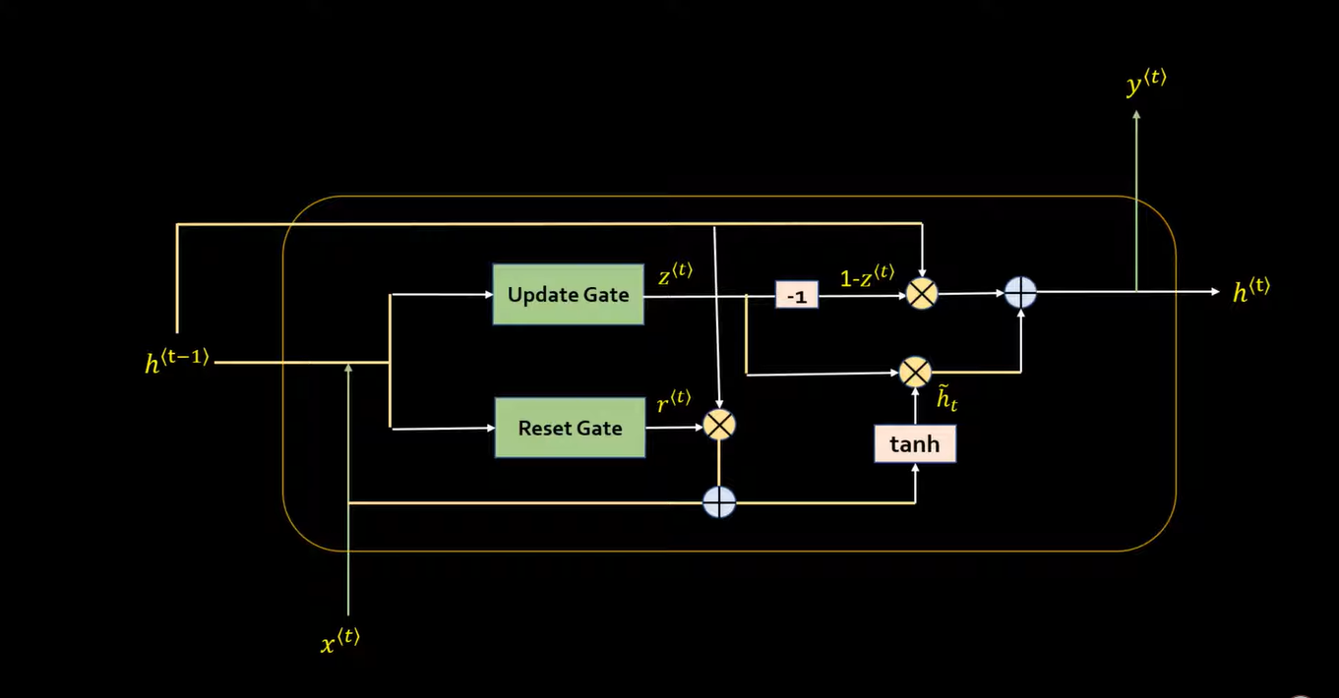

Working of reset 🡪 forget samosa and put pasta in short term memory.  
Working of update 🡪 do not forget pasta but update cheese with pasta

ht’ = tanh(( w * xt + b ) + (( w * ht-1 + b ) * rt ))) * zt  
ht’’ = (1-zt) * (ht-1)   
ht = ht’ + ht’’  
if zt = 1 then it means we are not performing update.

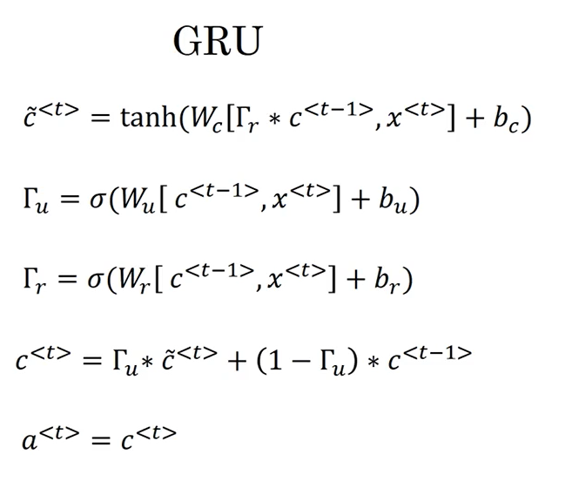

**Conclusion**

LSTM is more accurate but requires more computations as it has more gates than the GRU however, GRU is simpler, and requires less computations because it only has two gates.

**Bidirectional Recurrent Neural Network**

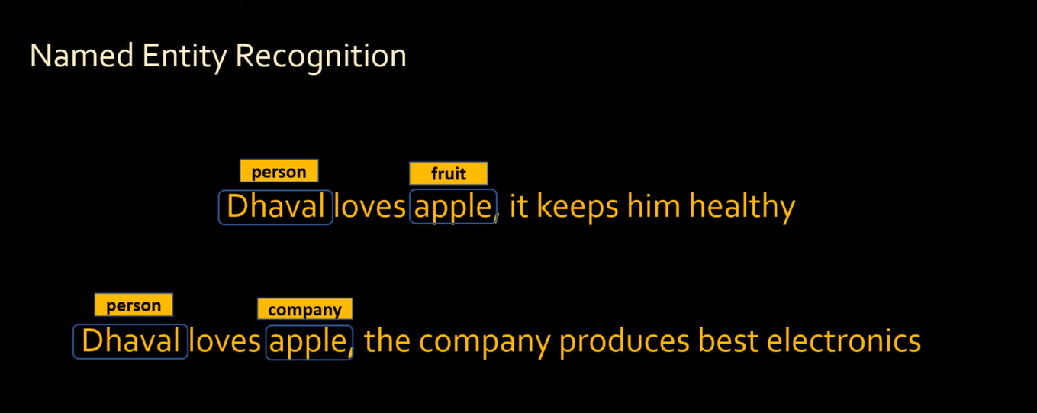

Suppose if we want to classify word (Named Entity Recognition) then for proper and accurate classification, we need information of future words/data in our sentence. The example given below shows that apple is a fruit as well as a company and its classification we need knowledge of the remaining sentence as well because we can not classify apply but just reading half context of the sentence as apple can be a fruit or it can also be a company.

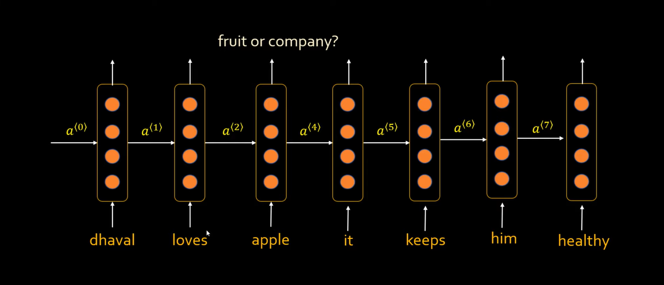

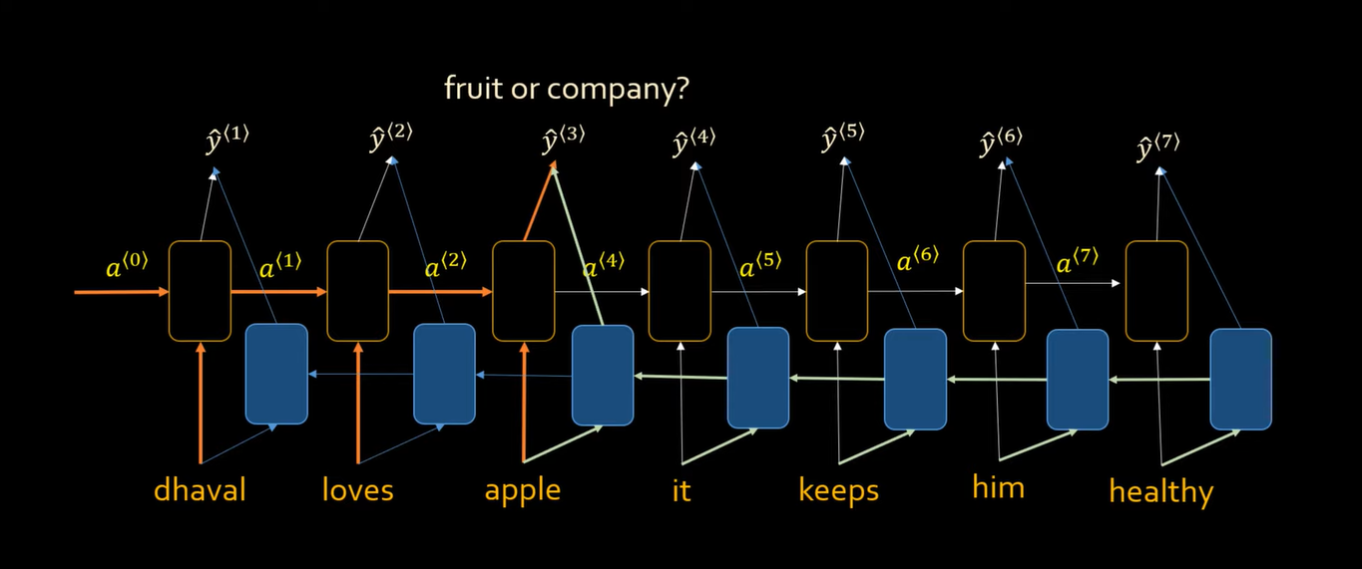

For such problems, we use bidirectional RNN and use the same recurrent neural network from opposite direction so that we can have knowledge of the future words in a sentence.

**Attention Models**

